The first IDEO card selected was *Surveys and Questionnaire*s. This strategy was selected to gauge the experience levels of potential app users and their needs. We wanted to understand:

* How comfortable users feel with plants without an aide,
* How current plant owners own and handle plants,
* Whether non-plant owners would like to own plants and if so, what stop them, and
* Common issues plant owners struggle with.

Towards this goal, we created a survey. At the beginning of the survey, participants were asked about their general comfort level with plants and whether they own plants. Depending on their response, they were then asked questions geared towards either plant owners or non-plant owners. Finally, all participants were asked about common issues with plant care and how they might interact with a plant care app.

Of the 18 participants in the survey, about 60% owned plants while 40% did not. Comfort level with plants varied, but none of the participants felt fully confident in their ability to care for plants. In fact, most of the current plant owners avoid owning plants that require special care, and over half do not know what plants they own.

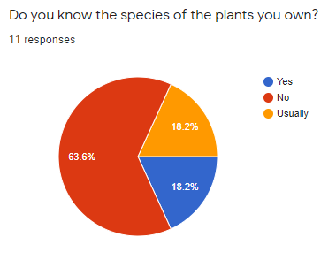

*Figure X: Distribution of plant owner responses to the question “Do you know the species of plants you own?”*

For non-plant owners, we were pleased to see that as we had hoped, most would be open to owning plants. The largest barrier to owning plants was fear of killing plants. This makes sense, as two thirds of all participants had killed a plant before, with about half of plant deaths occurring for unknown reasons.

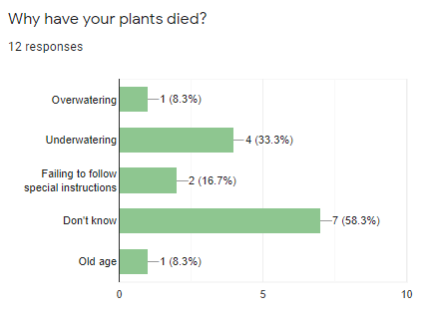

*Figure X: Reasons participants thought their plants had died.*

These reasons corresponded well with app features suggested by participants. The most commonly requested features included guides for setup and care, and care reminders.